Monthly Performance Report – June 2026
Kestrel Ridge Wind Farm (75.6 MW)
David Chen · 09 July 2026 · KR-OPS-RPT-2026-06

1. Summary
Kestrel Ridge generated 11.2 GWh in June 2026, 0.9 % above the P50 budget of 11.1 GWh. Time-based availability was strong at 97.5 % (contract target 97.0 %). Mean hub-height wind speed of 6.9 m/s was close to the long-term mean (6.7 m/s). Compared with June 2025 (10.2 GWh), output was up 1.0 GWh.

2. Production and key figures
KPI | June 2026 | Budget / target | YTD 2026 | YTD budget
Net generation (GWh) | 11.2 | 11.1 | 106.8 | 110.1
Time-based availability | 97.5 % | 97.0 % | 96.7 % | 97.0 %
Capacity factor | 20.6 % | 20.4 % | 32.5 % | –
Mean wind speed at hub height (m/s) | 6.9 | 6.7 | – | –
Source: Kestrel Ridge SCADA, revenue meter at 132 kV point of connection. Budget = P50 (2024 post-construction yield assessment).
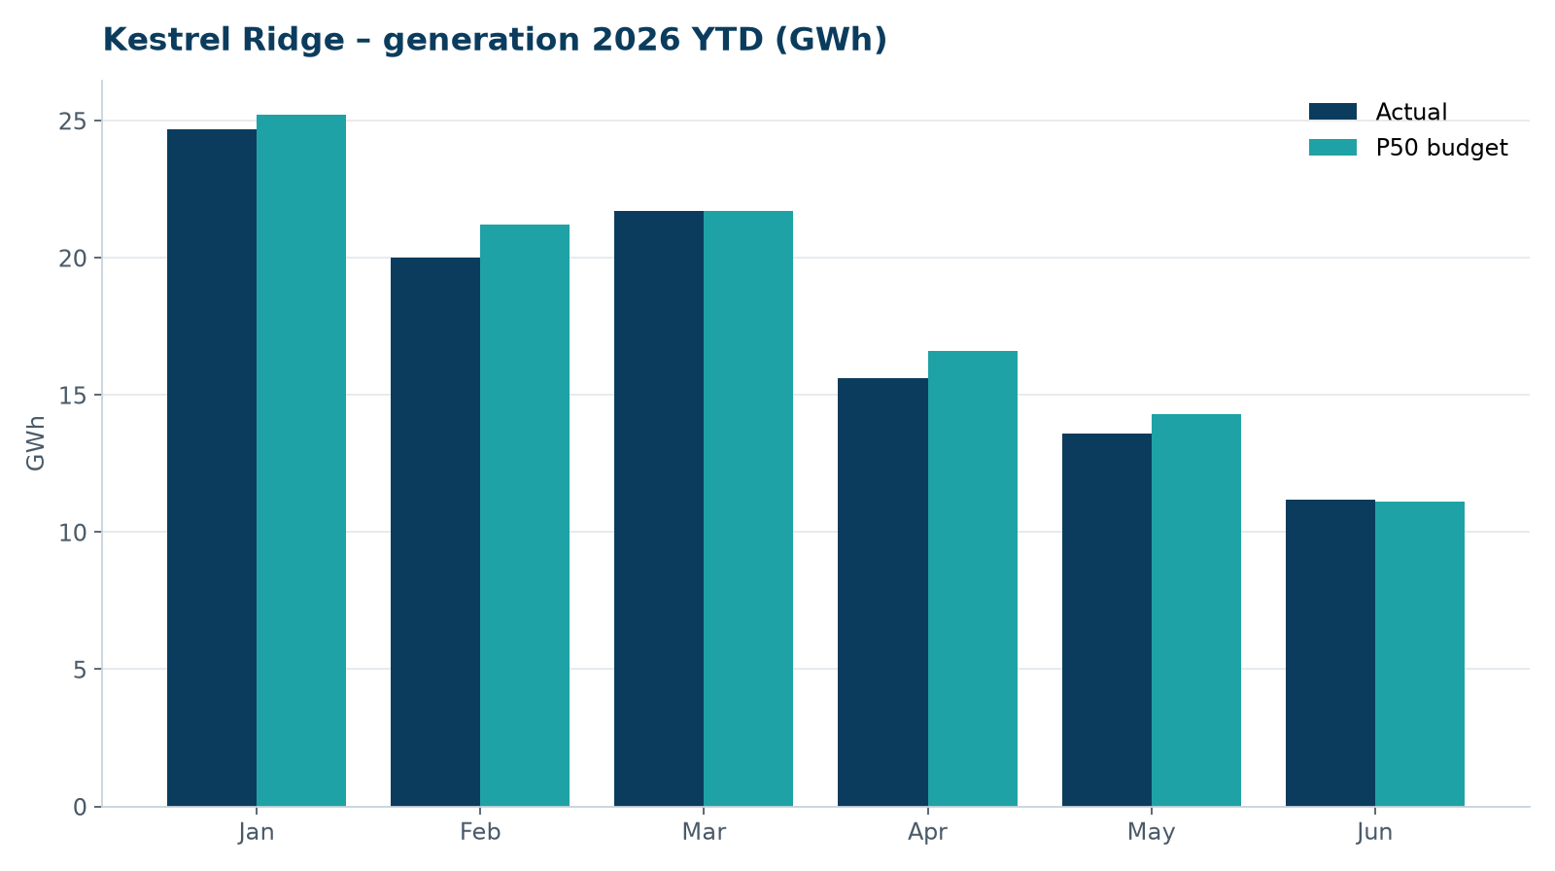
Monthly generation vs. P50 budget, 2026 year to date

3. Availability and downtime
Total turbine downtime attributable to the contractor amounted to 23 turbine-hours for the top events listed below. No grid or force majeure exclusions were claimed this month.
Turbine | Event | Downtime (h)
T-18 | pitch motor encoder fault on blade B | 10
T-01 | yaw brake pad wear – pads replaced | 9
T-05 | tower base controller communication loss | 4
Top downtime events of the month (SCADA event log, reviewed with Highline Wind Services).

4. Maintenance
- Annual service: 4 turbines completed this month.
- 17 corrective work orders closed, 3 still open at month end.
- Monthly safety equipment checks (fall arrest, rescue kits, fire extinguishers) completed on all towers.

5. Health, safety and environment
Indicator | Month
Hours worked on site (Highline + Weyland) | 4,870
Lost time injuries | 0
First aid cases | 1
Near misses reported | 1
Safety observations | 14
Environmental incidents | 0

No environmental incidents. Bird carcass searches were carried out on schedule (fortnightly, all turbines).

6. Outlook
Next month's focus: closing open corrective work orders and preparing the quarterly O&M review with Highline Wind Services.
Prepared by Sara Lindgren (Performance Analyst); reviewed by Ben Okoye (Site Manager) and David Chen (Asset Operations Manager).

